# **Name: Abdurrahman Qureshi**

# **Roll No: 210451**

Practical No: 2

**1)Display Hello World**

**CODE:**

Module Module1

Sub Main()

Console.WriteLine("Hello World")

Console.ReadLine()

End Sub

End Module

**OUTPUT:**

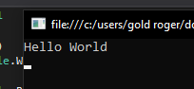

**2)Display User name**

**CODE:**

Module Module1

Sub Main()

Dim userName As String

userName = InputBox("Enter your name:")

Console.WriteLine("Entered name is : " & userName)

Console.ReadLine()

End Sub

End Module

**OUTPUT:**

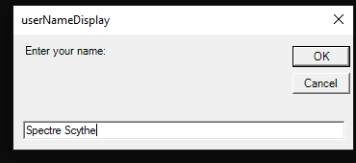

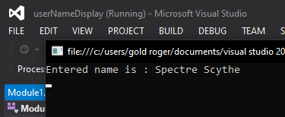

**3)Arithmetic Menu**

**CODE:**

Module Module1

Sub Main()

Dim a As Integer

Dim b As Integer

Dim c As Char

a = InputBox("Enter first Number")

b = InputBox("Enter Second Number")

c = InputBox("Enter operator")

Select Case (c)

Case "+"

Console.ReadLine("Addition = " & a + b)

Case "-"

Console.ReadLine("Subtraction = " & a - b)

Case "*"

Console.ReadLine("Multiplication = " & a * b)

Case "/"

Console.ReadLine("Division = " & a / b)

End Select

End Sub

End Module

**OUTPUT:**

